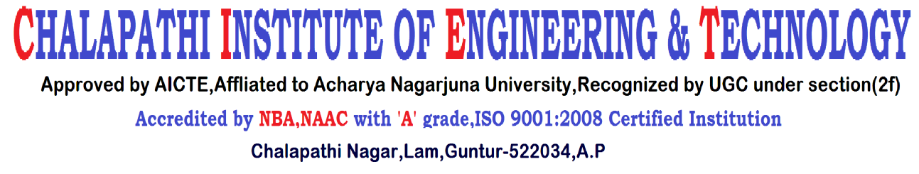

**DEPARTMENT OF ELECTRICAL AND ELECTRONICS ENGINEERING**

Date: 23-03-2019

To

The Principal,

Chalapathi Institute of Engineering and Technology,

Lam, Guntur

Sir,

Sub: Budget proposal for the financial year 2019-20 – reg.

With reference to the subject cited I am here with submitting budget proposal details for an amount of Rs. **16,60,000/- (Rupees Sixteen Lakh Sixty Thousand Only)** for the financial year 2019-20.

**BUDGET PROPOSAL**

|  |  |  |
| --- | --- | --- |
| **Description** | | **Budget**  **Proposed**  **(in Rs.)** |
| Laboratory/Department Development | * Major Equipment (Establishment of Computer Lab with 30 Systems) * Minor Equipment * Software Purchase (MATLAB License) * Maintenance/Calibration * Lab Consumable * Teaching Aids (LCD Projector) * Computer Maintenance/Repair   (Project Lab) | 10,50,000  -  2,50,000  40,000  20,000  70,000  5,000 |
| Faculty / Staff Development | * Seminars/Workshops/Conferences * Summer/Winter Schools * Organizing FDP * Professional Society Membership * Incentives & Rewards | 20,000  10,000  20,000  10,000  10,000 |
| **Description** | | **Budget**  **Proposed**  **(in Rs.)** |
| In-House Research | * In house Research Activities * Research Publication | 30,000  15,000 |
| Students Development | * Paper Presentation/Quiz Etc * Organizing Inter Dept. Events * Organizing Inter Insti. Events * Professional Society Memberships * Organizing Personality Devel. Progs. * Programs on Ethics & Entrepr. * Organizing Alumni Events * Students’ Incentives & Rewards * Training & Travel * Conference /Publication | 5,000  5,000  10,000  5,000  5,000  5,000  5,000  10,000  10,000  10,000 |
|  | * Stationary * Books and Journals * Miscellaneous | 5,000  15,000  20,000 |
| **Total** | | **Rs 16,60,000/-** |

**Budget in-charge Head of the Department**